**Project Report on**

***Hotel Reservation System***

***Introduction***

The project is based on on-site hotel reservation system. It allows guests and members of the application to place reservation(s), and the admins may approve or disapprove the bookings. The application is written on Python 3.7 and uses the Kivy module for Graphical User Interface.

This project is aimed towards hotels where reservation may be allowed by on-site displayed tablets or computers connected to the same host, i.e. the hotels reservation system server.

***Structure of UI***

The following table shows the flow of screens/pages for the application;

|  |  |  |  |
| --- | --- | --- | --- |
| Guest | Reservation form screen | | |
| Member | Login | Reservation form Screen | Delete my account screen |
| Admin | Login | Confirmation Screen | Booked rooms Screen |
| Checked-in rooms Screen |
| New Admin Screen |
| Create room Screen |
| Delete my account Screen |
| New | Member create Screen | | |
| Rooms | View rooms Screen | | |

On launch of the app, the users are prompted to make a selection whether they want to reserve a hotel room as a guest or member, or check for available room types, its costs, and availability of those rooms. The administrative of the reservation system can log in through here as well.

To check for available rooms, prices, room capacity, guests can click on the ‘Rooms’ button.

The rooms are arranged in ascending order of room number.

Guest members are able to place bookings directly after filing out the reservation forms. The emails and phone numbers entered are checked, and the check-in and check-out dates are checked whether they are in correct format or not. These dates cannot be the same and cannot be in the past.

Member account holders can log into their accounts and place reservations similarly, but most of their common data will be saved, so they can make reservations quickly. They also have the ability to delete their accounts themselves.

Hotel guests wanting to make their accounts are able to do so themselves by clicking of the ‘New’ button on the home page. They will get an unique Member ID and their input data will also be checked to make sure they are in correct format. They will be prompted to re-enter their passwords to make sure they are aware of their own password.

Admins can log into administration account by logging in thorough their unique Admin ID and password. The first screen displayed after logging in to the administration account is the reservation rooms which are yet to be processed. The admin can select multiple rows of data and either accept them or decline the reservations. The processed reservations are moved to the booked rooms screen, from where the admins are able to check-in the guests. After check-in, the data is moved to the checked-in screen, where the admins are able to check out the guests and the cost of the total period of stay is displayed beside each guest data. After checking out the guests, the data is deleted. Admins are also able to create new rooms, new admins and may also delete their admin account.

***Databases***

The Database Management System used is MySQL. It is used to store data of member information, admin information, all available rooms, requested rooms, booked rooms and checked in rooms.

The database name is “hotel_management” and the following are the tables included in it :

* admin_info – For all the admin information
* booked_rooms – For all the rooms which have been verified by admin
* checked_in – For all the rooms which have been checked in by the guest
* member_info – For all the member information
* requested_rooms – For all the rooms which have been requested by guest/member users
* rooms – For the rooms that are created by admin or are already existing

mysql> use hotel_management;

Reading table information for completion of table and column names

You can turn off this feature to get a quicker startup with -A

Database changed

mysql> show tables;

+----------------------------+

| Tables_in_hotel_management |

+----------------------------+

| admin_info |

| booked_rooms |

| checked_in |

| member_info |

| requested_rooms |

| rooms |

+----------------------------+

6 rows in set (0.00 sec)

1. *admin_info structure*

mysql> desc admin_info;

+-------------------+-------------+------+-----+---------+-------+

| Field | Type | Null | Key | Default | Extra |

+-------------------+-------------+------+-----+---------+-------+

| admin_id | varchar(10) | NO | PRI | NULL | |

| admin_phonenumber | varchar(15) | NO | | NULL | |

| admin_email | varchar(50) | NO | | NULL | |

| admin_name | varchar(25) | NO | | NULL | |

| admin_password | varchar(25) | NO | | NULL | |

+-------------------+-------------+------+-----+---------+-------+

5 rows in set (0.00 sec)

1. *booked_rooms structure*

mysql> desc booked_rooms;

+-------------+-------------+------+-----+---------+-------+

| Field | Type | Null | Key | Default | Extra |

+-------------+-------------+------+-----+---------+-------+

| room_no | varchar(5) | NO | MUL | NULL | |

| id | varchar(10) | NO | MUL | NULL | |

| phonenumber | varchar(15) | NO | | NULL | |

| email | varchar(50) | NO | | NULL | |

| name | varchar(25) | NO | | NULL | |

| check_in | date | NO | | NULL | |

| check_out | date | NO | | NULL | |

+-------------+-------------+------+-----+---------+-------+

7 rows in set (0.00 sec)

1. *checked_in structure*

mysql> desc checked_in;

+------------+-------------+------+-----+---------+-------+

| Field | Type | Null | Key | Default | Extra |

+------------+-------------+------+-----+---------+-------+

| room_no | varchar(5) | NO | | NULL | |

| id | varchar(10) | NO | | NULL | |

| name | varchar(25) | NO | | NULL | |

| checked_in | date | NO | | NULL | |

| check_out | date | NO | | NULL | |

+------------+-------------+------+-----+---------+-------+

5 rows in set (0.00 sec)

1. *member_info structure*

mysql> desc member_info;

+--------------------+-------------+------+-----+---------+-------+

| Field | Type | Null | Key | Default | Extra |

+--------------------+-------------+------+-----+---------+-------+

| member_id | varchar(10) | NO | PRI | NULL | |

| member_phonenumber | varchar(15) | NO | | NULL | |

| member_email | varchar(50) | NO | | NULL | |

| member_name | varchar(25) | NO | | NULL | |

| member_password | varchar(25) | NO | | NULL | |

+--------------------+-------------+------+-----+---------+-------+

5 rows in set (0.00 sec)

1. *requested_rooms structure*

mysql> desc requested_rooms;

+-------------+-------------+------+-----+---------+-------+

| Field | Type | Null | Key | Default | Extra |

+-------------+-------------+------+-----+---------+-------+

| room_type | varchar(25) | NO | | NULL | |

| id | varchar(10) | NO | | NULL | |

| phonenumber | varchar(15) | NO | | NULL | |

| name | varchar(25) | NO | | NULL | |

| no_guests | int | NO | | NULL | |

| check_in | date | NO | | NULL | |

| check_out | date | NO | | NULL | |

+-------------+-------------+------+-----+---------+-------+

7 rows in set (0.00 sec)

1. *rooms structure*

mysql> desc rooms;

+-------------------+-------------+------+-----+---------+-------+

| Field | Type | Null | Key | Default | Extra |

+-------------------+-------------+------+-----+---------+-------+

| room_no | varchar(5) | NO | PRI | NULL | |

| room_type | varchar(25) | NO | | NULL | |

| room_availability | char(1) | YES | | NULL | |

| room_capacity | int | NO | | NULL | |

| room_price | int | NO | | NULL | |

+-------------------+-------------+------+-----+---------+-------+

5 rows in set (0.00 sec)

***Functions in the program***

The home screen has three large-sized function, namely ‘Guest’ (to call the screen for room reservation as guest), ‘Member’ (to call the member login screen), ‘Admin’ (to login to the application as an administrative member). Following these functions are the two functions ‘New’ and ‘Rooms’ for loading the screen where new member accounts can be created and the screen which displays all the room details respectively.

1. *The guest screen*

The guest is prompted to fill out a form which inputs his/her name, phone number, choice of room type, number of guests, expected check-in and check-out date. The phone number is checked where it is in proper format (xxx-xxxx-xxxx) and must not include alphabets. The room type is selected through a drop-down list of all the available types of rooms and by default is set to ‘Select’. Similarly, the number of guests is selected through a drop-down list ranging from one to 10. The check-in and the check-out text inputs have the same structure, where the inputs are checked and must be in the correct format (yyyy-mm-dd).

If the form has any empty or invalid inputs, also including leaving the drop-down entry set to the default value, the data is not processed and a popup is displayed. If the form is filled out successfully, a popup is displayed stating that the reservation was sent for approval.

1. *The member login screen*

This screen has two input boxes for the ‘Member ID’ and ‘Password’ for the member. The id is checked whether it is existing in the database and the password to the corresponding id. If any input is left empty or the id and the password don’t match the database values, a popup is displayed stating login error.

After the member is through with the login phase, he/she is presented to a similar form from the guest reservation screen. The member is to select preferable room type and number of guests, and fill out the check-in and check-out dates. If the member successfully fills out the form, a popup is displayed stating that the request has been sent for Admin confirmation and is returned to the Home Screen.

1. *The admin login screen*

Similar to the member login screen, here the admin is prompted to fill out his/her ‘Admin ID’ and ‘Password’ for the admin. The inputs are checked in the database whether they are present and correspond to the id. If any input is left empty or the id and the password don’t match the database values, a popup is displayed stating login error.

The admin confirmation screen is displayed after the admin is through the login phase. The screen has all the requested rooms by guests and members, where the admin can select them by clicking on the check-boxes beside each row of request and either decline the reservations or accept them. Either the case, a popup is displayed stating the fore-mentioned reply for the request is successfully deleted or confirmed. If the request is accepted, the selected rows of requests are moved to booked_rooms table of the database. The room number is selected by the program on its own and marked as availability equals to ‘N’ in the table Rooms of the database.

The admin confirmation screen has five other functions in it which can be called by clicking on the respective buttons which are displayed on the top of the screen.

* + 1. The booked rooms screen can be called through the button on the upper right hand corner. This screen is similar to the data presented in the admin confirmation screen but these are already processed/accepted. The admin can check-in each row or multiple rows of reserved rooms by checking the check-box beside each room and clicking on the ‘Checked In Now’ button on the bottom of the screen. When the guest checks into their room, the records are deleted from the booked_rooms table and moved to the checked_in table in the databases. And similarly moved from the booked rooms screen to the checked-in rooms screen.
    2. The checked-in rooms screen can be called by clicking on the button on the upper right corner, below the booked rooms button. The rows of data presented here are from the guests/members who have checked-in to their rooms. The total cost is displayed up-to date beside each row. The admin can check-out each row or multiple rows of checked-in rooms by checking the check-box beside each room and clicking on the ‘Checked Out Now’ button on the bottom of the screen. When the guest checks out of their room, the records are deleted from the checked_in table and also removed from the current screen.
    3. The create new admin screen can be called from the button on the top of the current screen. This screen has a form to be filled out which is for the creation of the new admin account. If the required inputs are empty or invalid, an error is popped out, and if the details are correct the account is created. The new account is saved in the admin_info table of the database.
    4. To access the screen for creating a new room, the admin can click on the button ‘Create room’ on the top of the admin confirmation screen. The screen is displayed and prompts to fill out the input boxes , ‘Room Number’, ‘Room Type’, ‘Room Capacity’ and ‘Room Price’. If the inputs are left empty, an error popup is displayed stating that the room could not be created. After successful room creation, the details are inserted into the rooms table of the database and the rooms screen is refreshed.
    5. For deleting the admin account, there is a button ‘Delete My Account’ on the top of the admin confirmation page. On pressing the button, a popup is displayed asking whether you want to delete the account or not. If the delete button is pressed, the screen is brought back to the Home screen and the admin account is deleted from the admin_info table.

1. *Member account creation screen*

The ‘New’ screen has a button to call the Member account creation page. Similar to the admin create page, this page has text input boxes which must be filled for creating a member account. The inputs are checked, and if they are empty or invalid, a popup is displayed stating account creation failure. If the inputs are valid, a new member account is created in the member_info table in the database and a popup is displayed stating account creation was successful. The home screen is called back.

1. *Rooms screen*

On pressing the rooms button on the lower right corner of the home screen, the rooms screen is displayed. All the rooms are displayed on a scroll view.

***Code***

import random

import mysql.connector as connector

from datetime import datetime, date

from kivy.app import App

from kivy.uix.gridlayout import GridLayout

from kivy.uix.floatlayout import FloatLayout

from kivy.uix.scrollview import ScrollView

from kivy.core.window import Window

from kivy.uix.textinput import TextInput

from kivy.uix.button import Button

from kivy.uix.label import Label

from kivy.graphics import Color, Rectangle

from kivy.uix.screenmanager import ScreenManager, Screen

from kivy.uix.popup import Popup

from kivy.uix.checkbox import CheckBox

from kivy.uix.dropdown import DropDown

"""

/usr/local/mysql/bin/mysql -u root -p

"""

# creating database if not exists

def mysql():

mycon = connector.connect(user='root', password='avishek2002')

cursor = mycon.cursor()

cursor.execute('show databases;')

databases = cursor.fetchall()

condition = ''

for database in databases:

if "hotel_management" == database[0]:

condition = "Exists"

break

else:

condition = "Does not exist"

if condition != "Exists":

cursor.execute('create database if not exists hotel_management;')

cursor.execute('use hotel_management;')

cursor.execute('create table admin_info(admin_id varchar(10) primary key not null);')

cursor.execute('alter table admin_info add(admin_phonenumber varchar(15) not null);')

cursor.execute('alter table admin_info add(admin_email varchar(50) not null);')

cursor.execute('alter table admin_info add(admin_name varchar(25) not null);')

cursor.execute('alter table admin_info add(admin_password varchar(25) not null)')

cursor.execute('create table member_info (member_id varchar(10) primary key not null);')

cursor.execute('alter table member_info add(member_phonenumber varchar(15) not null);')

cursor.execute('alter table member_info add(member_email varchar(50) not null);')

cursor.execute('alter table member_info add(member_name varchar(25) not null);')

cursor.execute('alter table member_info add(member_password varchar(25) not null);')

cursor.execute('create table rooms (room_no varchar(5) primary key not null);')

cursor.execute("alter table rooms add(room_type varchar(25) not null);")

cursor.execute('alter table rooms add(room_availability char(1));')

cursor.execute('alter table rooms add(room_capacity int(2) not null);')

cursor.execute('alter table rooms add(room_price int(5) not null);')

cursor.execute('create table booked_rooms(room_no varchar(5) not null);')

cursor.execute('alter table booked_rooms add(foreign key(room_no) references rooms(room_no));')

cursor.execute('alter table booked_rooms add(id varchar(10) not null);')

cursor.execute('alter table booked_rooms add(foreign key(id) references member_info(member_id));')

cursor.execute('alter table booked_rooms add(phonenumber varchar(15) not null);')

cursor.execute('alter table booked_rooms add(email varchar(50) not null);')

cursor.execute('alter table booked_rooms add(name varchar(25) not null);')

cursor.execute('alter table booked_rooms add(check_in date not null);')

cursor.execute('alter table booked_rooms add(check_out date not null);')

cursor.execute('create table requested_rooms(room_type varchar(25) not null);')

cursor.execute('alter table requested_rooms add(id varchar(10) not null);')

cursor.execute('alter table requested_rooms add(phonenumber varchar(15) not null);')

cursor.execute('alter table requested_rooms add(name varchar(25) not null);')

cursor.execute('alter table requested_rooms add(no_guests int(2) not null);')

cursor.execute('alter table requested_rooms add(check_in date not null);')

cursor.execute('alter table requested_rooms add(check_out date not null);')

cursor.execute("create table checked_in(room_no varchar(5) not null);")

cursor.execute("alter table checked_in add(id varchar(10) not null);")

cursor.execute("alter table checked_in add(name varchar(25) not null);")

cursor.execute("alter table checked_in add(checked_in date not null);")

cursor.execute("alter table checked_in add(check_out date not null);")

mycon.commit()

mycon.close()

else:

return

mysql()

mycon = connector.connect(user='root', password='avishek2002', database='hotel_management')

cursor = mycon.cursor()

# getting available rooms

def available_rooms():

cursor.execute("select * from rooms;")

rooms = cursor.fetchall()

return rooms

# getting requested rooms

def requested_rooms():

cursor.execute("select * from requested_rooms;")

rooms = cursor.fetchall()

return rooms

# getting booked rooms

def booked_rooms():

cursor.execute("select * from booked_rooms;")

rooms = cursor.fetchall()

return rooms

# getting checked in rooms

def checked_rooms():

cursor.execute("select * from checked_in;")

rooms = cursor.fetchall()

return rooms

# getting room type

def room_types():

cursor.execute("select distinct(room_type) from rooms;")

room_type = cursor.fetchall()

return room_type

# getting admin information

def admin_info():

cursor.execute("select * from admin_info;")

data = cursor.fetchall()

return data

# getting member information

def member_info():

cursor.execute("select * from member_info;")

data = cursor.fetchall()

return data

# incorrect login details

def popup_incorrect():

# incorrect login details screen

class popup_incorrect_screen(FloatLayout):

def __init__(self, **kwargs):

super(popup_incorrect_screen, self).__init__(**kwargs)

self.label = Label(text="ID or Password is incorrect!", font_size=50, color=(1, 0, 0, 1),

size_hint=(.4, .2), pos_hint={"x": 0.3, "top": .75}, text_size=(600, None),

halign="center")

self.add_widget(self.label)

self.back = Button(text="Try Again", font_size=25, background_color=(0, 225, 225, 1),

color=(225, 225, 225, 1),

size_hint=(.4, .15), pos_hint={"x": 0.3, "top": 0.3})

self.back.bind(on_release=self.call_back)

self.add_widget(self.back)

def call_back(self, instances):

popupWindow.dismiss()

pass

show = popup_incorrect_screen()

popupWindow = Popup(title="Login Error", content=show, size_hint=(None, None), size=(650, 600),

pos=(0, 0), auto_dismiss=False)

popupWindow.open()

# invalid room reservation submission

def popup_invalid_submission():

# invalid room reservation submission screen

class popup_invalid_screen(FloatLayout):

def __init__(self, **kwargs):

super(popup_invalid_screen, self).__init__(**kwargs)

self.label = Label(text="The text boxes must not be left empty and must be in correct format!",

font_size=50, color=(1, 0, 0, 1), size_hint=(.4, .2), pos_hint={"x": 0.3, "top": .75},

text_size=(600, None), halign="center")

self.add_widget(self.label)

self.back = Button(text="Re-try submitting form", font_size=25, background_color=(0, 225, 225, 1),

color=(225, 225, 225, 1),

size_hint=(.42, .15), pos_hint={"x": 0.3, "top": 0.3})

self.back.bind(on_release=self.call_back)

self.add_widget(self.back)

def call_back(self, instances):

invalidWindow.dismiss()

pass

show = popup_invalid_screen()

invalidWindow = Popup(title="Submission Error", content=show, size_hint=(None, None), size=(650, 600),

pos=(0, 0), auto_dismiss=False)

invalidWindow.open()

# valid room reservation submission

def popup_valid_submission():

# valid room reservation submission screen

class popup_valid_screen(FloatLayout):

def __init__(self, **kwargs):

super(popup_valid_screen, self).__init__(**kwargs)

self.label = Label(text="Successfully sent request for room reservation!", text_size=(600, None),

halign="center", font_size=50, color=(1, 0, 0, 1), size_hint=(.4, .2),

pos_hint={"x": 0.3, "top": .75})

self.add_widget(self.label)

self.back = Button(text="Return to Home Screen", font_size=25, background_color=(0, 225, 225, 1),

color=(225, 225, 225, 1),

size_hint=(.4, .15), pos_hint={"x": 0.3, "top": 0.3})

self.back.bind(on_release=self.call_back)

self.add_widget(self.back)

def call_back(self, instances):

validWindow.dismiss()

sm.transition.direction = 'right'

sm.current = 'Home'

pass

show = popup_valid_screen()

validWindow = Popup(title="Submission success", content=show, size_hint=(None, None), size=(650, 600),

pos=(0, 0), auto_dismiss=False)

validWindow.open()

# confirm reservations as Admin

def popup_confirm():

# confirm reservation screen

class popup_confirm_screen(FloatLayout):

def __init__(self, **kwargs):

super(popup_confirm_screen, self).__init__(**kwargs)

self.label = Label(text="Confirmed reservations for the selected rooms!", text_size=(600, None),

halign="center", font_size=50, color=(1, 0, 0, 1), size_hint=(.4, .2),

pos_hint={"x": 0.3, "top": .75})

self.add_widget(self.label)

self.back = Button(text="Return to your Page", font_size=25, background_color=(0, 225, 225, 1),

color=(225, 225, 225, 1),

size_hint=(.4, .15), pos_hint={"x": 0.3, "top": 0.3})

self.back.bind(on_release=self.call_back)

self.add_widget(self.back)

def call_back(self, instances):

confirmWindow.dismiss()

pass

show = popup_confirm_screen()

confirmWindow = Popup(title="Confirmation success", content=show, size_hint=(None, None), size=(650, 600),

pos=(0, 0), auto_dismiss=False)

confirmWindow.open()

# deleteing reservations as Admin

def popup_confirm_delete():

# delete reservation screen

class popup_confirm_screen(FloatLayout):

def __init__(self, **kwargs):

super(popup_confirm_screen, self).__init__(**kwargs)

self.label = Label(text="Deleted reservations for the selected rooms!", text_size=(600, None),

halign="center", font_size=50, color=(1, 0, 0, 1), size_hint=(.4, .2),

pos_hint={"x": 0.3, "top": .75})

self.add_widget(self.label)

self.back = Button(text="Return to your Page", font_size=25, background_color=(0, 225, 225, 1),

color=(225, 225, 225, 1),

size_hint=(.4, .15), pos_hint={"x": 0.3, "top": 0.3})

self.back.bind(on_release=self.call_back)

self.add_widget(self.back)

def call_back(self, instances):

confirmWindow.dismiss()

pass

show = popup_confirm_screen()

confirmWindow = Popup(title="Deletion success", content=show, size_hint=(None, None), size=(650, 600),

pos=(0, 0), auto_dismiss=False)

confirmWindow.open()

# generating admin id

def makeid():

cursor.execute('select admin_id from admin_info;')

data = cursor.fetchall()

if data != "":

ID = 'A'

while True:

for i in range(0, 3):

ID += str(random.randrange(0, 10))

if ID not in data:

break

else:

continue

else:

ID = "A001"

return ID

# creating admin acoount

def create_admin(id_, phone, email, name, password):

cursor.execute("insert into admin_info(admin_id,admin_phonenumber,admin_email,admin_name,admin_password) "

"values('{}','{}','{}','{}','{}')".format(id_, phone, email, name, password))

mycon.commit()

return

# deleting admin account

def adminaccountdelete(admin_identifier):

cursor.execute("delete from admin_info where admin_id = '{}'".format(admin_identifier))

mycon.commit()

return

# generating member id

def makememberid():

cursor.execute('select member_id from member_info;')

data = cursor.fetchall()

if data != "":

ID = 'M'

while True:

for i in range(0,3):

ID += str(random.randrange(0,10))

if ID not in data:

break

else:

continue

else:

ID = "M001"

return ID

# creating member account

def create_member(ID, phone_number, email, name, password):

cursor.execute("insert into member_info(member_id,member_phonenumber,member_email,member_name,"

"member_password) values('{}','{}','{}','{}','{}')"

.format(ID, phone_number, email, name, password))

mycon.commit()

return

# deleting member account and its data

def member_delete(ID):

cursor.execute("set foreign_key_checks = 0")

cursor.execute("delete from member_info where member_id='{}'".format(ID))

cursor.execute("delete from requested_rooms where id = '{}'".format(ID))

cursor.execute("delete from booked_rooms where id = '{}'".format(ID))

cursor.execute("set foreign_key_checks = 1")

mycon.commit()

return

# account created

def popup_account_created():

# account created screen

class account_created_screen(FloatLayout):

def __init__(self, **kwargs):

super(account_created_screen, self).__init__(**kwargs)

self.label = Label(text="Your Account has been successfully created!", text_size=(600, None),

halign="center", font_size=50, color=(1, 0, 0, 1), size_hint=(.4, .2),

pos_hint={"x": 0.3, "top": .75})

self.add_widget(self.label)

self.back = Button(text="Home", font_size=25, background_color=(0, 225, 225, 1),

color=(225, 225, 225, 1),

size_hint=(.4, .15), pos_hint={"x": 0.3, "top": 0.3})

self.back.bind(on_release=self.call_back)

self.add_widget(self.back)

def call_back(self, instances):

accountWindow.dismiss()

sm.transition.direction = 'right'

sm.current = 'Home'

pass

show = account_created_screen()

accountWindow = Popup(title="Account Created", content=show, size_hint=(None, None), size=(650, 600),

pos=(0, 0), auto_dismiss=False)

accountWindow.open()

# account creation failure

def popup_account_notcreated():

# account creation failure screen

class account_notcreated_screen(FloatLayout):

def __init__(self, **kwargs):

super(account_notcreated_screen, self).__init__(**kwargs)

self.label = Label(text="Your Account could not be processed!", text_size=(600, None), halign="center",

font_size=50, color=(1, 0, 0, 1), size_hint=(.4, .2), pos_hint={"x": 0.3, "top": .75})

self.add_widget(self.label)

self.back = Button(text="Try Again", font_size=25, background_color=(0, 225, 225, 1),

color=(225, 225, 225, 1),

size_hint=(.4, .15), pos_hint={"x": 0.3, "top": 0.3})

self.back.bind(on_release=self.call_back)

self.add_widget(self.back)

def call_back(self, instances):

failureWindow.dismiss()

pass

show = account_notcreated_screen()

failureWindow = Popup(title="ERROR", content=show, size_hint=(None, None), size=(650, 600),

pos=(0, 0), auto_dismiss=False)

failureWindow.open()

# member account delete

def popup_member_delete():

# member account delete screen

class member_delete_screen(FloatLayout):

def __init__(self, **kwargs):

super(member_delete_screen, self).__init__(**kwargs)

self.label = Label(text="Your Account has been deleted!", text_size=(600, None), halign="center",

font_size=50, color=(1, 0, 0, 1), size_hint=(.4, .2), pos_hint={"x": 0.3, "top": .75})

self.add_widget(self.label)

self.back = Button(text="Back", font_size=25, background_color=(0, 225, 225, 1),

color=(225, 225, 225, 1),

size_hint=(.4, .15), pos_hint={"x": 0.3, "top": 0.3})

self.back.bind(on_release=self.call_back)

self.add_widget(self.back)

def call_back(self, instances):

memberdeleteWindow.dismiss()

sm.transition.direction = 'right'

sm.current = 'Home'

pass

show = member_delete_screen()

memberdeleteWindow = Popup(title="DELETED", content=show, size_hint=(None, None), size=(650, 600),

pos=(0, 0), auto_dismiss=False)

memberdeleteWindow.open()

# member account delete failure

def popup_member_delete_failure():

# member account delete failure screen

class member_delete_failure_screen(FloatLayout):

def __init__(self, **kwargs):

super(member_delete_failure_screen, self).__init__(**kwargs)

self.label = Label(text="Your Account could not deleted!", text_size=(600, None), halign="center",

font_size=50, color=(1, 0, 0, 1), size_hint=(.4, .2), pos_hint={"x": 0.3, "top": .75})

self.add_widget(self.label)

self.back = Button(text="Retry", font_size=25, background_color=(0, 225, 225, 1),

color=(225, 225, 225, 1),

size_hint=(.4, .15), pos_hint={"x": 0.3, "top": 0.3})

self.back.bind(on_release=self.call_back)

self.add_widget(self.back)

def call_back(self, instances):

memberdeletefailWindow.dismiss()

pass

show = member_delete_failure_screen()

memberdeletefailWindow = Popup(title="ERROR", content=show, size_hint=(None, None), size=(650, 600),

pos=(0, 0), auto_dismiss=False)

memberdeletefailWindow.open()

# admin account delete cornfirmation

def popup_confirm_admindelete():

# admin account delete confirmation screen

class admin_delete_confirmation_screen(FloatLayout):

def __init__(self, **kwargs):

super(admin_delete_confirmation_screen, self).__init__(**kwargs)

self.label = Label(text="Are you sure you want to delete this Admin Account!", text_size=(600, None),

halign="center", font_size=50, color=(1, 0, 0, 1), size_hint=(.4, .2),

pos_hint={"x": 0.3, "top": .75})

self.add_widget(self.label)

self.back = Button(text="Cancel", font_size=25, background_color=(0, 225, 225, 1),

color=(225, 225, 225, 1), size_hint=(.4, .15), pos_hint={"x": 0.1, "top": 0.3})

self.back.bind(on_release=self.call_back)

self.add_widget(self.back)

self.delete = Button(text="Delete", font_size=25, background_color=(0, 225, 225, 1),

color=(225, 225, 225, 1), size_hint=(.4, .15), pos_hint={"x": 0.5, "top": 0.3})

self.delete.bind(on_release=self.call_delete)

self.add_widget(self.delete)

def call_back(self, instances):

admindeleteconfirmationWindow.dismiss()

def call_delete(self, instances):

global admin_identifier

adminaccountdelete(admin_identifier)

admindeleteconfirmationWindow.dismiss()

sm.transition.direction = "right"

sm.current = "Home"

pass

show = admin_delete_confirmation_screen()

admindeleteconfirmationWindow = Popup(title="Confirm", content=show, size_hint=(None, None), size=(650, 600),

pos=(0, 0), auto_dismiss=False)

admindeleteconfirmationWindow.open()

# creating room details

def create_room(roomno, roomcap, roomtype, roomprice):

roomavailability = "Y"

cursor.execute("insert into rooms(room_no,room_type,room_availability,room_capacity,room_price)"

"values('{}','{}','{}','{}','{}')".format(roomno, roomtype, roomavailability, roomcap, roomprice))

mycon.commit()

return

# room created

def popup_room_created():

# room created screen

class room_created_screen(FloatLayout):

def __init__(self, **kwargs):

super(room_created_screen, self).__init__(**kwargs)

self.label = Label(text="Room Created!", halign="center", text_size=(600, None),

font_size=50, color=(1, 0, 0, 1), size_hint=(.4, .2), pos_hint={"x": 0.3, "top": .75})

self.add_widget(self.label)

self.back = Button(text="Back", font_size=25, background_color=(0, 225, 225, 1),

color=(225, 225, 225, 1),

size_hint=(.4, .15), pos_hint={"x": 0.3, "top": 0.3})

self.back.bind(on_release=self.call_back)

self.add_widget(self.back)

def call_back(self, instances):

roomWindow.dismiss()

sm.transition.direction = 'right'

sm.current = 'AdminConfirmation'

pass

show = room_created_screen()

roomWindow = Popup(title="Success", content=show, size_hint=(None, None), size=(650, 600),

pos=(0, 0), auto_dismiss=False)

roomWindow.open()

# room creation failure

def popup_room_notcreated():

# room creation failure screen

class room_notcreated_screen(FloatLayout):

def __init__(self, **kwargs):

super(room_notcreated_screen, self).__init__(**kwargs)

self.label = Label(text="Room could not be created!", halign="center", text_size=(600, None),

font_size=50, color=(1, 0, 0, 1), size_hint=(.4, .2), pos_hint={"x": 0.3, "top": .75})

self.add_widget(self.label)

self.back = Button(text="Try Again", font_size=25, background_color=(0, 225, 225, 1),

color=(225, 225, 225, 1),

size_hint=(.4, .15), pos_hint={"x": 0.3, "top": 0.3})

self.back.bind(on_release=self.call_back)

self.add_widget(self.back)

def call_back(self, instances):

failureWindow.dismiss()

pass

show = room_notcreated_screen()

failureWindow = Popup(title="ERROR", content=show, size_hint=(None, None), size=(650, 600),

pos=(0, 0), auto_dismiss=False)

failureWindow.open()

# inserting value into requested_rooms as guest

def request_room(name, phone, room_type, noofquests, check_in, check_out):

cursor.execute("insert into requested_rooms(room_type,id,phonenumber,name,no_guests,check_in,check_out)"

"values('{}','{}','{}','{}',{},'{}','{}')"

.format(room_type, 'GUEST', phone, name, noofquests, check_in, check_out))

mycon.commit()

return

# inserting value into requested_rooms as member

def request_room_asmember(ID, room_type, noofquests, check_in, check_out):

cursor.execute("select * from member_info where member_id = '{}';".format(ID))

data = cursor.fetchall()

phone = data[0][1]

name = data[0][3]

cursor.execute("insert into requested_rooms(room_type,id,phonenumber,name,no_guests,check_in,check_out)"

"values('{}','{}','{}','{}',{},'{}','{}')"

.format(room_type, ID, phone, name, noofquests, check_in, check_out))

mycon.commit()

return

# moving requested_room to booked_rooms

def move_to_booked_rooms(idx):

name = idx

cursor.execute("set foreign_key_checks = 0")

cursor.execute("select * from requested_rooms where name='{}'".format(name))

data = cursor.fetchone()

if data[1] != "GUEST":

cursor.execute("select * from member_info where member_name='{}'".format(name))

more_data = cursor.fetchone()

id_ = data[1]

phone = data[2]

email = more_data[2]

name = name

check_in = data[5]

check_out = data[6]

room_type = data[0]

# checking if there is free room for the above room type

cursor.execute("select room_no,room_availability from rooms where room_type='{}'".format(room_type))

rooms_data = cursor.fetchall()

for room_data in rooms_data:

room_no = room_data[0]

room_availability = room_data[1]

if room_availability == 'Y':

cursor.execute("insert into booked_rooms(room_no,id,phonenumber,email,name,check_in,check_out)"

"values('{}','{}','{}','{}','{}','{}','{}')"

.format(room_no, id_, phone, email, name, check_in, check_out))

cursor.execute("alter table booked_rooms order by check_in")

cursor.execute("delete from requested_rooms where name='{}'".format(name))

cursor.execute("update rooms set room_availability='N' where room_no='{}'".format(room_no))

mycon.commit()

break

else:

continue

else:

print("NO ROOM")

elif data[1] == "GUEST":

id_ = data[1]

phone = data[2]

name = name

check_in = data[5]

check_out = data[6]

room_type = data[0]

email = "NULL"

# checking if there is free room for the above room type

cursor.execute("select room_no,room_availability from rooms where room_type='{}'".format(room_type))

rooms_data = cursor.fetchall()

for room_data in rooms_data:

room_no = room_data[0]

room_availability = room_data[1]

if room_availability == 'Y':

cursor.execute("insert into booked_rooms(room_no,id,phonenumber,email,name,check_in,check_out)"

"values('{}','{}','{}','{}','{}','{}','{}')"

.format(room_no, id_, phone, email, name, check_in, check_out))

cursor.execute("alter table booked_rooms order by check_in")

cursor.execute("delete from requested_rooms where name='{}'".format(name))

cursor.execute("update rooms set room_availability='N' where room_no='{}'".format(room_no))

mycon.commit()

break

else:

continue

else:

print("NO ROOM")

cursor.execute("set foreign_key_checks = 1")

return

# deleting requests from requested_rooms

def delete_requestedroom(idx):

name = idx

cursor.execute("delete from requested_rooms where name='{}'".format(name))

mycon.commit()

return

# moving booked_rooms to checked_in

def checked_in_rooms(idx):

name = idx

cursor.execute("select * from booked_rooms where name = '{}'".format(name))

data = cursor.fetchone()

room_no = data[0]

ID = data[1]

checked_in = datetime.today().strftime('%Y-%m-%d')

check_out = data[6]

cursor.execute("insert into checked_in(room_no,id,name,checked_in,check_out)"

"values('{}','{}','{}','{}','{}')".format(room_no, ID, name, checked_in, check_out))

cursor.execute("delete from booked_rooms where name = '{}'".format(name))

mycon.commit()

return

# checking out guests and opening the room

def check_out(idx):

name = idx

cursor.execute("select * from checked_in where name = '{}'".format(name))

data = cursor.fetchone()

room_no = data[0]

cursor.execute("delete from checked_in where name = '{}'".format(name))

cursor.execute("update rooms set room_availability = 'Y' where room_no = '{}'".format(room_no))

mycon.commit()

return

# Home page

class Home(Screen, FloatLayout):

def __init__(self, **kwargs):

super(Home, self).__init__(**kwargs)

with self.canvas:

Color(1, 1, 0, 1)

self.rect = Rectangle(size=(3000, 2000))

self.label = Label(text="Select an option: ", font_size=75, color=(225, 225, 225, 1), size_hint=(.4, .3),

pos_hint={"x": 0.31, "top": 1})

self.add_widget(self.label)

self.guest = Button(text="Guest", font_size=40, background_color=(0, 225, 225, 1), color=(225, 225, 225, 1),

size_hint=(.4, .15), pos_hint={"x": 0.3, "top": .7})

self.guest.bind(on_release=self.call_guest)

self.add_widget(self.guest)

self.member = Button(text="Member", font_size=40, background_color=(0, 225, 225, 1), color=(225, 225, 225, 1),

size_hint=(.4, .15), pos_hint={"x": 0.3, "top": 0.5})

self.member.bind(on_release=self.call_member)

self.add_widget(self.member)

self.admin = Button(text="Admin", font_size=40, background_color=(0, 225, 225, 1), color=(225, 225, 225, 1),

size_hint=(.4, .15), pos_hint={"x": 0.3, "top": 0.3})

self.admin.bind(on_release=self.call_admin)

self.add_widget(self.admin)

self.create = Button(text='NEW', font_size=30, background_color=(0, 225, 225, 1), color=(225, 225, 225, 1),

size_hint=(.15, .1), pos_hint={"x": 0.05, "top": 0.15})

self.create.bind(on_release=self.call_create)

self.add_widget(self.create)

self.rooms = Button(text='ROOMS', font_size=30, background_color=(0, 225, 225, 1), color=(225, 225, 225, 1),

size_hint=(.15, .1), pos_hint={"x": 0.8, "top": .15})

self.rooms.bind(on_release=self.call_rooms)

self.add_widget(self.rooms)

def call_guest(self, instances):

sm.transition.direction = 'left'

sm.current = 'GuestReservation'

def call_member(self, instances):

sm.transition.direction = 'left'

sm.current = 'MemberLogin'

def call_admin(self, instances):

sm.transition.direction = 'left'

sm.current = 'AdminLogin'

def call_create(self, instances):

sm.transition.direction = 'up'

sm.current = 'Create'

def call_rooms(self, instances):

sm.transition.direction = 'up'

sm.current = 'Rooms'

pass

# Create account screen (middle screen for Member signup screen)

class Create(Screen, FloatLayout):

def __init__(self, **kwargs):

super(Create, self).__init__(**kwargs)

with self.canvas:

Color(1, 1, 0, 1)

self.rect = Rectangle(size=(3000, 2000))

self.label = Label(text="Account Creation Page", font_size=75, color=(225, 225, 225, 1), size_hint=(.4, .3),

pos_hint={"x": 0.31, "top": 1})

self.add_widget(self.label)

self.createmember = Button(text="Become a member", font_size=40, background_color=(0, 225, 225, 1),

color=(225, 225, 225, 1), size_hint=(.4, .15), pos_hint={"x": 0.3, "top": 0.55})

self.createmember.bind(on_release=self.call_createmember)

self.add_widget(self.createmember)

self.home = Button(text="Home", font_size=25, background_color=(0, 225, 225, 1), color=(225, 225, 225, 1),

size_hint=(.15, .025), pos_hint={"x": 0.01, "top": .99})

self.home.bind(on_release=self.call_home)

self.add_widget(self.home)

def call_home(self, instances):

sm.transition.direction = 'down'

sm.current = 'Home'

def call_createmember(self, instances):

sm.transition.direction = 'left'

sm.current = 'Createmember'

pass

# Rooms screen

class Rooms(Screen, FloatLayout):

def __init__(self, **kwargs):

super(Rooms, self).__init__(**kwargs)

with self.canvas:

Color(1, 1, 0, 1)

self.rect = Rectangle(size=(3000, 2000))

self.label = Label(text="Room Selection", font_size=75, color=(225, 225, 225, 1), size_hint=(.4, .3),

pos_hint={"x": 0.31, "top": 1})

self.add_widget(self.label)

x = [0.2, 0.35, 0.5, 0.65, 0.8]

top = 0.75

header_string = ['Room No.', 'Room Type', 'Available', 'Capacity', 'Price(¥)']

for i in range(0, len(header_string)):

self.header = Label(text=header_string[i], font_size=40, color=(225, 225, 225, 1), size_hint=(0, 0),

pos_hint={'x': x[i], 'top': top})

self.add_widget(self.header)

self.layout = GridLayout(cols=5, spacing=40, size_hint_y=None)

self.layout.bind(minimum_height=self.layout.setter('height'))

rooms = available_rooms()

x = [0.2, 0.35, 0.5, 0.65, 0.8]

top = 0.8

def lining():

for i in range(0, 5):

self.room = Label(text="", font_size=25, color=(225, 225, 225, 1),

pos_hint={'x': x[i], 'top': top})

self.layout.add_widget(self.room)

return

lining()

for room in rooms:

for i in range(0, len(room)):

self.room = Label(text=str(room[i]), font_size=25, color=(225, 225, 225, 1),

pos_hint={'x': x[i], 'top': top})

self.layout.add_widget(self.room)

top -= .05

lining()

self.root = ScrollView(size_hint=(None, None), size=(Window.width * .75, Window.height * .6),

pos_hint={"x": 0.125, 'top': 0.675})

self.root.add_widget(self.layout)

self.add_widget(self.root)

self.home = Button(text="Home", font_size=25, background_color=(0, 225, 225, 1), color=(225, 225, 225, 1),

size_hint=(.15, .025), pos_hint={"x": 0.01, "top": .99})

self.home.bind(on_release=self.call_home)

self.add_widget(self.home)

def call_home(self, instances):

sm.transition.direction = 'down'

sm.current = 'Home'

pass

# Booked rooms screen

class BookedRooms(Screen, FloatLayout):

def __init__(self, **kwargs):

super(BookedRooms, self).__init__(**kwargs)

with self.canvas:

Color(1, 1, 0, 1)

self.rect = Rectangle(size=(3000, 2000))

self.label = Label(text="Booked Rooms", font_size=75, color=(225, 225, 225, 1), size_hint=(.4, .3),

pos_hint={"x": 0.31, "top": 1})

self.add_widget(self.label)

x = [0.1, 0.175, 0.3, 0.45, 0.6, 0.75, 0.9]

top = 0.75

header_string = ['Room No.', 'ID', 'Phone Number', 'Email', 'Name', 'Check-in', 'Check-out']

for i in range(0, len(header_string)):

self.header = Label(text=header_string[i], font_size=40, color=(225, 225, 225, 1), size_hint=(0, 0),

pos_hint={'x': x[i], 'top': top})

self.add_widget(self.header)

rooms = booked_rooms()

x = [0.1, 0.175, 0.3, 0.45, 0.6, 0.75, 0.9, 0.8]

top = 0.7

self.checkref = {}

for room in rooms:

for i in range(0, len(room)):

self.room = Label(text=str(room[i]), font_size=25, color=(225, 225, 225, 1), size_hint=(.0, .0),

pos_hint={'x': x[i], 'top': top})

self.add_widget(self.room)

self.check = CheckBox(size_hint=(.02, .02), pos_hint={'x': x[7], 'top': top + 0.01}, active=False)

self.add_widget(self.check)

self.checkref[room[4]] = self.check

top -= 0.05

self.home = Button(text="Back", font_size=25, background_color=(0, 225, 225, 1), color=(225, 225, 225, 1),

size_hint=(.15, .025), pos_hint={"x": 0.01, "top": .99})

self.home.bind(on_release=self.call_home)

self.add_widget(self.home)

self.submit = Button(text="Checked In Now", font_size=40, background_color=(0, 225, 225, 1),

color=(225, 225, 225, 1), size_hint=(.4, .1), pos_hint={"x": 0.3, "top": 0.125})

self.submit.bind(on_release=self.call_confirm)

self.add_widget(self.submit)

def call_home(self, instances):

sm.transition.direction = 'right'

sm.current = 'AdminConfirmation'

def call_confirm(self, instances):

for idx, wgt in self.checkref.items():

if wgt.active:

checked_in_rooms(idx)

self.parent.get_screen('BookedRooms').__init__()

self.parent.get_screen('CheckedInRooms').__init__()

pass

# CheckedIn rooms screen

class CheckedInRooms(Screen, FloatLayout):

def __init__(self, **kwargs):

super(CheckedInRooms, self).__init__(**kwargs)

with self.canvas:

Color(1, 1, 0, 1)

self.rect = Rectangle(size=(3000, 2000))

self.label = Label(text="Checked-In Rooms", font_size=75, color=(225, 225, 225, 1), size_hint=(.4, .3),

pos_hint={"x": 0.31, "top": 1})

self.add_widget(self.label)

x = [0.1, 0.25, 0.4, 0.55, 0.7, 0.9]

top = 0.75

header_string = ['Room No.', 'ID', 'Name', 'Checked-in', 'Check-out', 'Current Cost(¥)']

for i in range(0, len(header_string)):

self.header = Label(text=header_string[i], font_size=40, color=(225, 225, 225, 1), size_hint=(0, 0),

pos_hint={'x': x[i], 'top': top})

self.add_widget(self.header)

rooms = checked_rooms()

x = [0.1, 0.25, 0.4, 0.55, 0.7, 0.8]

top = 0.7

self.checkref = {}

for room in rooms:

for i in range(0, len(room)):

self.room = Label(text=str(room[i]), font_size=25, color=(225, 225, 225, 1), size_hint=(.0, .0),

pos_hint={'x': x[i], 'top': top})

self.add_widget(self.room)

self.check = CheckBox(size_hint=(.02, .02), pos_hint={'x': x[5], 'top': top + 0.01}, active=False)

self.add_widget(self.check)

self.checkref[room[2]] = self.check

cursor.execute("select room_price from rooms where room_no='{}'".format(room[0]))

price = cursor.fetchone()

days_stayed = (date.today() - room[3]).days

curr_cost = days_stayed * price[0]

self.cost = Label(text=str(curr_cost), font_size=25, color=(225, 225, 225, 1), size_hint=(.0, .0),

pos_hint={'x': 0.9, 'top': top})

self.add_widget(self.cost)

top -= 0.05

self.home = Button(text="Back", font_size=25, background_color=(0, 225, 225, 1), color=(225, 225, 225, 1),

size_hint=(.15, .025), pos_hint={"x": 0.01, "top": .99})

self.home.bind(on_release=self.call_home)

self.add_widget(self.home)

self.refresh = Button(text="Refresh Page", font_size=35, background_color=(0, 225, 225, 1),

color=(225, 225, 225, 1), size_hint=(.2, .05), pos_hint={"x": 0.76, "top": .1})

self.refresh.bind(on_release=self.call_refresh)

self.add_widget(self.refresh)

self.submit = Button(text="Checked Out Now", font_size=40, background_color=(0, 225, 225, 1),

color=(225, 225, 225, 1), size_hint=(.4, .1), pos_hint={"x": 0.3, "top": 0.125})

self.submit.bind(on_release=self.call_confirm)

self.add_widget(self.submit)

def call_home(self, instances):

sm.transition.direction = 'right'

sm.current = 'AdminConfirmation'

def call_refresh(self, instances):

self.parent.get_screen('CheckedInRooms').__init__()

def call_confirm(self, instances):

for idx, wgt in self.checkref.items():

if wgt.active:

check_out(idx)

self.parent.get_screen('CheckedInRooms').__init__()

self.parent.get_screen('Rooms').__init__()

pass

# Guest reservation screen

class GuestReservation(Screen, FloatLayout):

def __init__(self, **kwargs):

super(GuestReservation, self).__init__(**kwargs)

with self.canvas:

Color(1, 1, 0, 1)

self.rect = Rectangle(size=(3000, 2000))

self.label = Label(text="Guest Reservation", font_size=75, color=(225, 225, 225, 1), size_hint=(.4, .3),

pos_hint={"x": 0.31, "top": 1})

self.add_widget(self.label)

self.name_label = Label(text="Name", font_size=40, color=(225, 225, 1, 1), size_hint=(.35, .05),

pos_hint={"x": 0.15, "top": 0.8})

self.add_widget(self.name_label)

self.nameofguest = TextInput(multiline=False, font_size=40, size_hint=(.35, .05),

pos_hint={"x": 0.5, "top": 0.8})

self.add_widget(self.nameofguest)

self.phone_label = Label(text="Phone Number", font_size=40, color=(225, 225, 1, 1), size_hint=(.35, .05),

pos_hint={"x": 0.15, "top": 0.7})

self.add_widget(self.phone_label)

self.phoneofguest = TextInput(multiline=False, font_size=40, size_hint=(.35, .05),

pos_hint={"x": 0.5, "top": 0.7})

self.add_widget(self.phoneofguest)

room_type = room_types()

self.room_label = Label(text="Room Type", font_size=40, color=(225, 225, 1, 1), size_hint=(.35, .05),

pos_hint={"x": 0.15, "top": 0.6})

self.add_widget(self.room_label)

self.dropdown = DropDown()

for room_type_ in room_type:

type = room_type_[0]

self.val = Button(text=type, color=(225, 225, 1, 1), background_color=(0, 225, 225, 1),

size_hint_y=None, height=44)

self.val.bind(on_release=lambda val: self.dropdown.select(val.text))

self.dropdown.add_widget(self.val)

self.roomofguest = Button(text='Select', color=(225, 225, 1, 1), background_color=(0, 225, 225, 1),

size_hint=(.35, .05), pos_hint={"x": 0.5, "top": 0.6})

self.roomofguest.bind(on_release=self.dropdown.open)

self.add_widget(self.roomofguest)

self.dropdown.bind(on_select=lambda instance, x: setattr(self.roomofguest, 'text', x))

self.noofguests_label = Label(text="Number of Guests", font_size=40, color=(225, 225, 1, 1),

size_hint=(.35, .05), pos_hint={"x": 0.15, "top": 0.5})

self.add_widget(self.noofguests_label)

self.dropdown2 = DropDown()

for num in range(1, 11):

self.val = Button(text=str(num), color=(225, 225, 1, 1), background_color=(0, 225, 225, 1),

size_hint_y=None, height=44)

self.val.bind(on_release=lambda val: self.dropdown2.select(val.text))

self.dropdown2.add_widget(self.val)

self.noofguest = Button(text='Select', color=(225, 225, 1, 1), background_color=(0, 225, 225, 1),

size_hint=(.35, .05), pos_hint={"x": 0.5, "top": 0.5})

self.noofguest.bind(on_release=self.dropdown2.open)

self.add_widget(self.noofguest)

self.dropdown2.bind(on_select=lambda instance, x: setattr(self.noofguest, 'text', x))

self.checkin_label = Label(text="Check-in Date", font_size=40, color=(225, 225, 1, 1), size_hint=(.35, .05),

pos_hint={"x": 0.15, "top": 0.4})

self.add_widget(self.checkin_label)

self.checkinofguest = TextInput(multiline=False, font_size=40, size_hint=(.35, .05),

pos_hint={"x": 0.5, "top": 0.4})

self.add_widget(self.checkinofguest)

self.checkout_label = Label(text="Check-out Date", font_size=40, color=(225, 225, 1, 1), size_hint=(.35, .05),

pos_hint={"x": 0.15, "top": 0.3})

self.add_widget(self.checkout_label)

self.checkoutofguest = TextInput(multiline=False, font_size=40, size_hint=(.35, .05),

pos_hint={"x": 0.5, "top": 0.3})

self.add_widget(self.checkoutofguest)

self.home = Button(text="Home", font_size=25, background_color=(0, 225, 225, 1), color=(225, 225, 225, 1),

size_hint=(.15, .025), pos_hint={"x": 0.01, "top": 0.99})

self.home.bind(on_release=self.call_home)

self.add_widget(self.home)

self.submit = Button(text="Submit form as Guest", font_size=40, background_color=(0, 225, 225, 1),

color=(225, 225, 225, 1), size_hint=(.4, .15), pos_hint={"x": 0.3, "top": 0.2})

self.submit.bind(on_release=self.guest_submit)

self.add_widget(self.submit)

def call_home(self, instances):

self.nameofguest.text = ""

self.phoneofguest.text = ""

self.roomofguest.text = "Select"

self.noofguest.text = "Select"

self.checkinofguest.text = ""

self.checkoutofguest.text = ""

sm.transition.direction = 'right'

sm.current = 'Home'

def guest_submit(self, instances):

name = self.nameofguest.text

phone = self.phoneofguest.text

room_type = self.roomofguest.text

noofquests = self.noofguest.text

check_in = self.checkinofguest.text

check_out = self.checkoutofguest.text

phoneCheck = ''

for i in range(0, len(phone)):

if phone[i] == "-":

phoneCheck = phoneCheck

else:

phoneCheck += phone[i]

continue

today = date.today()

if name != "" and phoneCheck.isnumeric() and room_type != "Select" and noofquests != "Select" and\

check_in > str(today) and check_out > str(today) and check_out > check_in:

request_room(name, phone, room_type, noofquests, check_in, check_out)

self.parent.get_screen('AdminConfirmation').__init__()

popup_valid_submission()

else:

popup_invalid_submission()

self.nameofguest.text = ""

self.phoneofguest.text = ""

self.roomofguest.text = "Select"

self.noofguest.text = "Select"

self.checkinofguest.text = ""

self.checkoutofguest.text = ""

pass

# Member login screen

class MemberLogin(Screen, FloatLayout):

def __init__(self, **kwargs):

super(MemberLogin, self).__init__(**kwargs)

with self.canvas:

Color(1, 1, 0, 1)

self.rect = Rectangle(size=(3000, 2000))

self.label = Label(text="Member Login", font_size=75, color=(225, 225, 225, 1), size_hint=(.4, .3),

pos_hint={"x": 0.31, "top": 1})

self.add_widget(self.label)

self.id_label = Label(text="Member ID", font_size=40, color=(225, 225, 1, 1), size_hint=(.35, .05),

pos_hint={"x": 0.15, "top": 0.65})

self.add_widget(self.id_label)

self.idofguest = TextInput(multiline=False, font_size=40, size_hint=(.35, .05),

pos_hint={"x": 0.5, "top": 0.65})

self.add_widget(self.idofguest)

self.password_label = Label(text="Password", font_size=40, color=(225, 225, 1, 1), size_hint=(.35, .05),

pos_hint={"x": 0.15, "top": 0.55})

self.add_widget(self.password_label)

self.passwordofguest = TextInput(multiline=False, password=True, font_size=40, size_hint=(.35, .05),

pos_hint={"x": 0.5, "top": 0.55})

self.add_widget(self.passwordofguest)

self.home = Button(text="Home", font_size=25, background_color=(0, 225, 225, 1), color=(225, 225, 225, 1),

size_hint=(.15, .025), pos_hint={"x": 0.01, "top": 0.99})

self.home.bind(on_release=self.call_home)

self.add_widget(self.home)

self.memberregistration = Button(text="Login", font_size=40, background_color=(0, 225, 225, 1),

color=(225, 225, 225, 1), size_hint=(.4, .15), pos_hint={"x": 0.3, "top": 0.3})

self.memberregistration.bind(on_release=self.call_memberreservation)

self.add_widget(self.memberregistration)

def call_home(self, instances):

self.idofguest.text = ""

self.passwordofguest.text = ""

sm.transition.direction = 'right'

sm.current = 'Home'

def call_memberreservation(self, instances):

ID = self.idofguest.text

global member_identifier

member_identifier = ID

password = self.passwordofguest.text

memberinfo = member_info()

state = ''

for member in memberinfo:

if ID in member and password in member:

self.parent.get_screen("MemberReservation").__init__()

sm.transition.direction = 'left'

sm.current = 'MemberReservation'

state = 'correct'

break

else:

state = 'incorrect'

if state == 'incorrect':

popup_incorrect()

self.idofguest.text = ""

self.passwordofguest.text = ""

pass

member_identifier = ""

mID = ''

# Member reservation screen

class MemberReservation(Screen, FloatLayout):

def __init__(self, **kwargs):

super(MemberReservation, self).__init__(**kwargs)

with self.canvas:

Color(1, 1, 0, 1)

self.rect = Rectangle(size=(3000, 2000))

self.label = Label(text='Member Reservation', font_size=75, color=(225, 225, 225, 1), size_hint=(.4, .3),

pos_hint={'x': 0.31, 'top': 1})

self.add_widget(self.label)

global member_identifier

self.id_label = Label(text="Member ID", font_size=40, color=(225, 225, 1, 1), size_hint=(.35, .05),

pos_hint={"x": 0.15, "top": 0.8})

self.add_widget(self.id_label)

self.idofmember = Label(text=member_identifier, color=(225, 225, 225, 1), font_size=40, size_hint=(.35, .05),

pos_hint={"x": 0.5, "top": 0.8})

self.add_widget(self.idofmember)

room_type = room_types()

self.room_label = Label(text="Room Type", font_size=40, color=(225, 225, 1, 1), size_hint=(.35, .05),

pos_hint={"x": 0.15, "top": 0.7})

self.add_widget(self.room_label)

self.dropdown = DropDown()

for room_type_ in room_type:

type = room_type_[0]

self.val = Button(text=type, color=(225, 225, 1, 1), background_color=(0, 225, 225, 1),

size_hint_y=None, height=44)

self.val.bind(on_release=lambda val: self.dropdown.select(val.text))

self.dropdown.add_widget(self.val)

self.room = Button(text='Select', color=(225, 225, 1, 1), background_color=(0, 225, 225, 1),

size_hint=(.35, .05), pos_hint={"x": 0.5, "top": 0.7})

self.room.bind(on_release=self.dropdown.open)

self.add_widget(self.room)

self.dropdown.bind(on_select=lambda instance, x: setattr(self.room, 'text', x))

self.noofguests_label = Label(text="Number of Guests", font_size=40, color=(225, 225, 1, 1),

size_hint=(.35, .05), pos_hint={"x": 0.15, "top": 0.6})

self.add_widget(self.noofguests_label)

self.dropdown2 = DropDown()

for num in range(1, 11):

self.val = Button(text=str(num), color=(225, 225, 1, 1), background_color=(0, 225, 225, 1),

size_hint_y=None, height=44)

self.val.bind(on_release=lambda val: self.dropdown2.select(val.text))

self.dropdown2.add_widget(self.val)

self.noofguests = Button(text='Select', color=(225, 225, 1, 1), background_color=(0, 225, 225, 1),

size_hint=(.35, .05), pos_hint={"x": 0.5, "top": 0.6})

self.noofguests.bind(on_release=self.dropdown2.open)

self.add_widget(self.noofguests)

self.dropdown2.bind(on_select=lambda instance, x: setattr(self.noofguests, 'text', x))

self.checkin_label = Label(text="Check-in Date", font_size=40, color=(225, 225, 1, 1),

size_hint=(.35, .05), pos_hint={"x": 0.15, "top": 0.5})

self.add_widget(self.checkin_label)

self.checkin = TextInput(multiline=False, font_size=40, size_hint=(.35, .05),

pos_hint={"x": 0.5, "top": 0.5})

self.add_widget(self.checkin)

self.checkout_label = Label(text="Check-out Date", font_size=40, color=(225, 225, 1, 1), size_hint=(.35, .05),

pos_hint={"x": 0.15, "top": 0.4})

self.add_widget(self.checkout_label)

self.checkout = TextInput(multiline=False, font_size=40, size_hint=(.35, .05),

pos_hint={"x": 0.5, "top": 0.4})

self.add_widget(self.checkout)

self.memberlogin = Button(text="Home", font_size=25, background_color=(0, 225, 225, 1),

color=(225, 225, 225, 1), size_hint=(.15, .025), pos_hint={"x": 0.01, "top": 0.99})

self.memberlogin.bind(on_release=self.call_memberlogin)

self.add_widget(self.memberlogin)

self.member_submit = Button(text="Submit form as Member", font_size=40, background_color=(0, 225, 225, 1),

color=(225, 225, 225, 1), size_hint=(.4, .15), pos_hint={"x": 0.3, "top": 0.3})

self.member_submit.bind(on_release=self.submit)

self.add_widget(self.member_submit)

self.delete = Button(text="Delete Acoount", font_size=25, background_color=(0, 225, 225, 1),

color=(225, 225, 225, 1), size_hint=(.15, .025), pos_hint={"x": 0.83, "top": 0.99})

self.delete.bind(on_release=self.call_delete)

self.add_widget(self.delete)

def call_memberlogin(self, instances):

self.idofmember.text = ""

self.room.text = "Select"

self.noofguests.text = "Select"

self.checkin.text = ""

self.checkout.text = ""

sm.transition.direction = 'right'

sm.current = 'Home'

def call_delete(self, instances):

self.parent.get_screen('MemberDelete').__init__()

sm.transition.direction = 'left'

sm.current = 'MemberDelete'

def submit(self, instances):

ID = member_identifier

room_type = self.room.text

noofquests = self.noofguests.text

check_in = self.checkin.text

check_out = self.checkout.text

today = date.today()

if ID != "" and room_type != "Select" and noofquests != "Select" and check_in > str(today) and\

check_out > str(today) and check_out > check_in:

request_room_asmember(ID, room_type, noofquests, check_in, check_out)

self.parent.get_screen('AdminConfirmation').__init__()

popup_valid_submission()

else:

popup_invalid_submission()

self.idofmember.text = ""

self.room.text = "Select"

self.noofguests.text = "Select"

self.checkin.text = ""

self.checkout.text = ""

pass

# Member signup screen

class Createmember(Screen, FloatLayout):

def __init__(self, **kwargs):

super(Createmember, self).__init__(**kwargs)

with self.canvas:

Color(1, 1, 0, 1)

self.rect = Rectangle(size=(3000, 2000))

self.label = Label(text="Member Sign Up", font_size=75, color=(225, 225, 225, 1), size_hint=(.4, .3),

pos_hint={"x": 0.31, "top": 1})

self.add_widget(self.label)

self.name_label = Label(text="Name", font_size=40, color=(225, 225, 1, 1), size_hint=(.35, .05),

pos_hint={"x": 0.15, "top": 0.8})

self.add_widget(self.name_label)

self.nameofmember = TextInput(multiline=False, font_size=40, size_hint=(.35, .05),

pos_hint={"x": 0.5, "top": 0.8})

self.add_widget(self.nameofmember)

self.phone_label = Label(text="Phone Number", font_size=40, color=(225, 225, 1, 1),

size_hint=(.35, .05), pos_hint={"x": 0.15, "top": 0.7})

self.add_widget(self.phone_label)

self.phoneofmember = TextInput(multiline=False, font_size=40, size_hint=(.35, .05),

pos_hint={"x": 0.5, "top": 0.7})

self.add_widget(self.phoneofmember)

self.email_label = Label(text="Email", font_size=40, color=(225, 225, 1, 1), size_hint=(.35, .05),

pos_hint={"x": 0.15, "top": 0.6})

self.add_widget(self.email_label)

self.emailofmember = TextInput(multiline=False, font_size=40, size_hint=(.35, .05),

pos_hint={"x": 0.5, "top": 0.6})

self.add_widget(self.emailofmember)

self.pass_label = Label(text="Password", font_size=40, color=(225, 225, 1, 1), size_hint=(.35, .05),

pos_hint={"x": 0.15, "top": 0.5})

self.add_widget(self.pass_label)

self.passofmember = TextInput(multiline=False, password=True, font_size=40, size_hint=(.35, .05),

pos_hint={"x": 0.5, "top": 0.5})

self.add_widget(self.passofmember)

self.pass2_label = Label(text="Confirm Password", font_size=40, color=(225, 225, 1, 1), size_hint=(.35, .05),

pos_hint={"x": 0.15, "top": 0.4})

self.add_widget(self.pass2_label)

self.pass2ofmember = TextInput(multiline=False, password=True, font_size=40, size_hint=(.35, .05),

pos_hint={"x": 0.5, "top": 0.4})

self.add_widget(self.pass2ofmember)

global mID

mID = makememberid()

self.id_label = Label(text="Your ID will be", font_size=40, color=(225, 225, 1, 1), size_hint=(.35, .05),

pos_hint={"x": 0.15, "top": 0.3})

self.add_widget(self.id_label)

self.id_value = Label(text=mID, font_size=40, color=(225, 225, 1, 1), size_hint=(.35, .05),

pos_hint={"x": 0.5, "top": 0.3})

self.add_widget(self.id_value)

self.home = Button(text="Home", font_size=25, background_color=(0, 225, 225, 1), color=(225, 225, 225, 1),

size_hint=(.15, .025), pos_hint={"x": 0.01, "top": .99})

self.home.bind(on_release=self.call_home)

self.add_widget(self.home)

self.submit = Button(text="Done", font_size=40, background_color=(0, 225, 225, 1), color=(225, 225, 225, 1),

size_hint=(.4, .15), pos_hint={"x": 0.3, "top": .2})

self.submit.bind(on_release=self.call_create_member)

self.add_widget(self.submit)

def call_home(self, instances):

self.nameofmember.text = ""

self.phoneofmember.text = ""

self.emailofmember.text = ""

self.passofmember.text = ""

self.pass2ofmember.text = ""

sm.transition.direction = 'right'

sm.current = 'Home'

def call_create_member(self, instances):

name = self.nameofmember.text

phone = self.phoneofmember.text

email = self.emailofmember.text

password = self.passofmember.text

password_check = self.pass2ofmember.text

global mID

phoneCheck = ''

for i in range(0, len(phone)):

if phone[i] == "-":

phoneCheck = phoneCheck

else:

phoneCheck += phone[i]

continue

mail_list = ['@gmail.com', '@yahoo.com', '@hotmail.com', '@aol.com', '@msn.com', '@icloud.com']

if '@' in email:

mail = email[email.index('@'):len(email)+1]

else:

mail = email

if name != '' and phoneCheck.isnumeric() and mail in mail_list and password != '' and\

password == password_check:

create_member(mID, phone, email, name, password)

self.parent.get_screen('Createmember').__init__()

popup_account_created()

else:

popup_account_notcreated()

self.nameofmember.text = ""

self.phoneofmember.text = ""

self.emailofmember.text = ""

self.passofmember.text = ""

self.pass2ofmember.text = ""

pass

# Delete my member account screen

class MemberDelete(Screen, FloatLayout):

def __init__(self, **kwargs):

super(MemberDelete, self).__init__(**kwargs)

with self.canvas:

Color(1, 1, 0, 1)

self.rect = Rectangle(size=(3000, 2000))

self.label = Label(text='Delete my Member account', font_size=75, color=(225, 225, 225, 1), size_hint=(.4, .3),

pos_hint={'x': 0.31, 'top': 1})

self.add_widget(self.label)

global member_identifier

self.id_label = Label(text="Member ID", font_size=40, color=(225, 225, 1, 1), size_hint=(.35, .05),

pos_hint={"x": 0.15, "top": 0.65})

self.add_widget(self.id_label)

self.idofmember = TextInput(text=member_identifier, multiline=False, font_size=40, size_hint=(.35, .05),

pos_hint={"x": 0.5, "top": 0.65})

self.add_widget(self.idofmember)

self.password_label = Label(text="Password", font_size=40, color=(225, 225, 1, 1), size_hint=(.35, .05),

pos_hint={"x": 0.15, "top": 0.55})

self.add_widget(self.password_label)

self.password = TextInput(multiline=False, password=True, font_size=40, size_hint=(.35, .05),

pos_hint={"x": 0.5, "top": 0.55})

self.add_widget(self.password)

self.memberconfirm = Button(text="Back", font_size=25, background_color=(0, 225, 225, 1),

color=(225, 225, 225, 1), size_hint=(.15, .025), pos_hint={"x": 0.01, "top": 0.99})

self.memberconfirm.bind(on_release=self.call_memberconfirmation)

self.add_widget(self.memberconfirm)

self.delete = Button(text="Confirm Delete", font_size=40, background_color=(0, 225, 225, 1),

color=(225, 225, 225, 1), size_hint=(.4, .15), pos_hint={"x": 0.3, "top": 0.3})

self.delete.bind(on_release=self.call_deleter)

self.add_widget(self.delete)

def call_memberconfirmation(self, instances):

self.idofmember.text = ""

self.password.text = ""

sm.transition.direction = 'right'

sm.current = 'MemberReservation'

def call_deleter(self, instances):

ID = self.idofmember.text

password = self.password.text

memberinfo = member_info()

state = ''

for member in memberinfo:

if ID in member and password in member:

member_delete(ID)

self.parent.get_screen("AdminConfirmation").__init__()

self.parent.get_screen("BookedRooms").__init__()

popup_member_delete()

state = 'correct'

self.idofmember.text = ""

break

else:

state = 'incorrect'

if state == 'incorrect':

popup_member_delete_failure()

self.password.text = ""

pass

# Admin login screen

class AdminLogin(Screen, FloatLayout):

def __init__(self, **kwargs):

super(AdminLogin, self).__init__(**kwargs)

with self.canvas:

Color(1, 1, 0, 1)

self.rect = Rectangle(size=(3000, 2000))

self.label = Label(text="Admin Login", font_size=75, color=(225, 225, 225, 1), size_hint=(.4, .3),

pos_hint={"x": 0.31, "top": 1})

self.add_widget(self.label)

self.id_label = Label(text="Admin ID", font_size=40, color=(225, 225, 1, 1), size_hint=(.35, .05),

pos_hint={"x": 0.15, "top": 0.65})

self.add_widget(self.id_label)

self.idofadmin = TextInput(multiline=False, font_size=40, size_hint=(.35, .05),

pos_hint={"x": 0.5, "top": 0.65})

self.add_widget(self.idofadmin)

self.password_label = Label(text="Password", font_size=40, color=(225, 225, 1, 1), size_hint=(.35, .05),

pos_hint={"x": 0.15, "top": 0.55})

self.add_widget(self.password_label)

self.passwordofadmin = TextInput(multiline=False, password=True, font_size=40, size_hint=(.35, .05),

pos_hint={"x": 0.5, "top": 0.55})

self.add_widget(self.passwordofadmin)

self.home = Button(text="Home", font_size=25, background_color=(0, 225, 225, 1), color=(225, 225, 225, 1),

size_hint=(.15, .025), pos_hint={"x": 0.01, "top": 0.99})

self.home.bind(on_release=self.call_home)

self.add_widget(self.home)

self.adminconfirmation = Button(text="Login", font_size=40, background_color=(0, 225, 225, 1),

color=(225, 225, 225, 1), size_hint=(.4, .15), pos_hint={"x": 0.3, "top": 0.3})

self.adminconfirmation.bind(on_release=self.call_adminconfirmation)

self.add_widget(self.adminconfirmation)

def call_home(self, instances):

self.idofadmin.text = ""

self.passwordofadmin.text = ""

sm.transition.direction = 'right'

sm.current = 'Home'

def call_adminconfirmation(self, instances):

ID = self.idofadmin.text

global admin_identifier

admin_identifier = ID

password = self.passwordofadmin.text

admininfo = admin_info()

state = ''

for admin in admininfo:

if ID in admin and password in admin:

self.parent.get_screen("AdminConfirmation").__init__()

sm.transition.direction = 'left'

sm.current = 'AdminConfirmation'

state = 'correct'

break

else:

state = 'incorrect'

if state == 'incorrect':

popup_incorrect()

self.idofadmin.text = ""

self.passwordofadmin.text = ""

pass

admin_identifier = ""

id_ = ''

# Admin room confirmation screen

class AdminConfirmation(Screen, FloatLayout):

def __init__(self, **kwargs):

super(AdminConfirmation, self).__init__(**kwargs)

with self.canvas:

Color(1, 1, 0, 1)

self.rect = Rectangle(size=(3000, 2000))

global admin_identifier

self.label = Label(text=admin_identifier, font_size=75, color=(225, 225, 225, 1),

size_hint=(.4, .1), pos_hint={'x': 0.31, 'top': 0.95})

self.add_widget(self.label)

self.label = Label(text='Admin Confirmation', font_size=75, color=(225, 225, 225, 1),

size_hint=(.4, .1), pos_hint={'x': 0.31, 'top': 0.875})

self.add_widget(self.label)

x = [0.15, 0.25, 0.335, 0.45, 0.55, 0.65, 0.75, 0.85]

top = 0.75

header_string = ['Room Type', 'ID', 'Phone No.', 'Name', 'No. of guests', 'Check-in', 'Check-out', 'Approve']

for i in range(0, len(header_string)):

self.header = Label(text=header_string[i], font_size=30, color=(225, 225, 225, 1), size_hint=(0, 0),

pos_hint={'x': x[i], 'top': top})

self.add_widget(self.header)

requested = requested_rooms()

self.checkref = {}

x = [0.15, 0.25, 0.335, 0.465, 0.55, 0.65, 0.75, 0.85]

top = 0.7

for request in requested:

for i in range(0, len(request)):

self.value = Label(text=str(request[i]), font_size=25, color=(225, 225, 225, 1), size_hint=(.0, .0),

pos_hint={'x': x[i], 'top': top})

self.add_widget(self.value)

self.check = CheckBox(size_hint=(.02, .02), pos_hint={'x': x[7], 'top': top + 0.01}, active=False)

self.add_widget(self.check)

self.checkref[request[3]] = self.check

top -= 0.05

self.submit = Button(text="Confirm reservation", font_size=40, background_color=(0, 225, 225, 1),

color=(225, 225, 225, 1), size_hint=(.4, .1), pos_hint={"x": 0.3, "top": 0.125})

self.submit.bind(on_release=self.call_confirm)

self.add_widget(self.submit)

self.delete = Button(text="Delete reservation", font_size=30, background_color=(0, 225, 225, 1),

color=(225, 225, 225, 1), size_hint=(.2, .05), pos_hint={"x": 0.05, "top": 0.1})

self.delete.bind(on_release=self.call_delete)

self.add_widget(self.delete)

self.home = Button(text="Home", font_size=25, background_color=(0, 225, 225, 1),

color=(225, 225, 225, 1), size_hint=(.15, .025), pos_hint={"x": 0.01, "top": 0.99})

self.home.bind(on_release=self.call_home)

self.add_widget(self.home)

self.view = Button(text="Booked rooms", font_size=25, background_color=(0, 225, 225, 1),

color=(225, 225, 225, 1), size_hint=(.15, .025), pos_hint={"x": 0.83, "top": 0.99})

self.view.bind(on_release=self.call_booked)

self.add_widget(self.view)

self.view2 = Button(text="Checked-In rooms", font_size=25, background_color=(0, 225, 225, 1),

color=(225, 225, 225, 1), size_hint=(.15, .025), pos_hint={"x": 0.83, "top": 0.96})

self.view2.bind(on_release=self.call_booked2)

self.add_widget(self.view2)

self.new_admin = Button(text="New Admin", font_size=25, background_color=(0, 225, 225, 1),

color=(225, 225, 225, 1), size_hint=(.15, .025), pos_hint={"x": 0.63, "top": 0.99})

self.new_admin.bind(on_release=self.call_newadmin)

self.add_widget(self.new_admin)

self.new_room = Button(text="Create room", font_size=25, background_color=(0, 225, 225, 1),

color=(225, 225, 225, 1), size_hint=(.15, .025), pos_hint={"x": 0.43, "top": 0.99})

self.new_room.bind(on_release=self.call_newroom)

self.add_widget(self.new_room)

self.admindelete = Button(text="Delete My Account", font_size=25, background_color=(0, 225, 225, 1),

color=(225, 225, 225, 1), size_hint=(.15, .025), pos_hint={"x": 0.23, "top": 0.99})

self.admindelete.bind(on_release=self.call_admindelete)

self.add_widget(self.admindelete)

def call_home(self, instances):

sm.transition.direction = 'right'

sm.current = 'Home'

def call_booked(self, instances):

sm.transition.direction = 'left'

sm.current = 'BookedRooms'

def call_booked2(self, instances):

sm.transition.direction = 'left'

sm.current = 'CheckedInRooms'

def call_newadmin(self, instanes):

sm.transition.direction = 'left'

sm.current = 'NewAdmin'

def call_newroom(self, instances):

sm.transition.direction = 'left'

sm.current = 'NewRoom'

def call_confirm(self, instances):

for idx, wgt in self.checkref.items():

if wgt.active:

move_to_booked_rooms(idx)

self.parent.get_screen('AdminConfirmation').__init__()

self.parent.get_screen('BookedRooms').__init__()

self.parent.get_screen('Rooms').__init__()

popup_confirm()

def call_delete(self, instances):

for idx, wgt in self.checkref.items():

if wgt.active:

delete_requestedroom(idx)

self.parent.get_screen('AdminConfirmation').__init__()

self.parent.get_screen('BookedRooms').__init__()

popup_confirm_delete()

def call_admindelete(self, instances):

popup_confirm_admindelete()

pass

# New admin account screen

class NewAdmin(Screen, FloatLayout):

def __init__(self, **kwargs):

super(NewAdmin, self).__init__(**kwargs)

with self.canvas:

Color(1, 1, 0, 1)

self.rect = Rectangle(size=(3000, 2000))

self.label = Label(text='Create New Admin', font_size=75, color=(225, 225, 225, 1),

size_hint=(.4, .3), pos_hint={'x': 0.31, 'top': 1})

self.add_widget(self.label)

self.phone_label = Label(text="Phone number", font_size=40, color=(225, 225, 1, 1), size_hint=(.35, .05),

pos_hint={"x": 0.15, "top": 0.8})

self.add_widget(self.phone_label)

self.phone = TextInput(multiline=False, font_size=40, size_hint=(.35, .05), pos_hint={"x": 0.5, "top": 0.8})

self.add_widget(self.phone)

self.email_label = Label(text="Email", font_size=40, color=(225, 225, 1, 1), size_hint=(.35, .05),

pos_hint={"x": 0.15, "top": 0.7})

self.add_widget(self.email_label)

self.email = TextInput(multiline=False, font_size=40, size_hint=(.35, .05), pos_hint={"x": 0.5, "top": 0.7})

self.add_widget(self.email)

self.name_label = Label(text="Name", font_size=40, color=(225, 225, 1, 1), size_hint=(.35, .05),

pos_hint={"x": 0.15, "top": 0.6})

self.add_widget(self.name_label)

self.name_ = TextInput(multiline=False, font_size=40, size_hint=(.35, .05), pos_hint={"x": 0.5, "top": 0.6})

self.add_widget(self.name_)

self.password_label = Label(text="Password", font_size=40, color=(225, 225, 1, 1), size_hint=(.35, .05),

pos_hint={"x": 0.15, "top": 0.5})

self.add_widget(self.password_label)

self.password = TextInput(multiline=False, password=True, font_size=40, size_hint=(.35, .05),

pos_hint={"x": 0.5, "top": 0.5})

self.add_widget(self.password)

self.pass2_label = Label(text="Confirm Password", font_size=40, color=(225, 225, 1, 1), size_hint=(.35, .05),

pos_hint={"x": 0.15, "top": 0.4})

self.add_widget(self.pass2_label)

self.pass2 = TextInput(multiline=False, password=True, font_size=40, size_hint=(.35, .05),

pos_hint={"x": 0.5, "top": 0.4})

self.add_widget(self.pass2)

global id_

id_ = makeid()

self.id_label = Label(text="Your ID will be", font_size=40, color=(225, 225, 1, 1), size_hint=(.35, .05),

pos_hint={"x": 0.15, "top": 0.3})

self.add_widget(self.id_label)

self.id_value = Label(text=id_, font_size=40, color=(225, 225, 1, 1), size_hint=(.35, .05),

pos_hint={"x": 0.5, "top": 0.3})

self.add_widget(self.id_value)

self.submit = Button(text="Create", font_size=40, background_color=(0, 225, 225, 1),

color=(225, 225, 225, 1), size_hint=(.4, .1), pos_hint={"x": 0.3, "top": 0.2})

self.submit.bind(on_release=self.call_confirm)

self.add_widget(self.submit)

self.home = Button(text="Back", font_size=25, background_color=(0, 225, 225, 1), color=(225, 225, 225, 1),

size_hint=(.15, .025), pos_hint={"x": 0.01, "top": 0.99})

self.home.bind(on_release=self.call_home)

self.add_widget(self.home)

def call_home(self, instances):

self.phone.text = ""

self.email.text = ""

self.name_.text = ""

self.password.text = ""

self.pass2.text = ""

sm.transition.direction = 'right'

sm.current = 'AdminConfirmation'

def call_confirm(self, instances):

phone = self.phone.text

email = self.email.text

name = self.name_.text

password = self.password.text

pass2 = self.pass2.text

global id_

phoneCheck = ''

for i in range(0, len(phone)):

if phone[i] == '-':

phoneCheck = phoneCheck

else:

phoneCheck += phone[i]

continue

mail_list = ['@gmail.com', '@yahoo.com', '@hotmail.com', '@aol.com', '@msn.com', '@icloud.com']

if '@' in email:

mail = email[email.index('@'):len(email) + 1]

else:

mail = email

if name != '' and phoneCheck.isnumeric() and mail in mail_list and password != '' and password == pass2:

create_admin(id_, phone, email, name, password)

self.parent.get_screen('NewAdmin').__init__()

popup_account_created()

else:

popup_account_notcreated()

self.phone.text = ""

self.email.text = ""

self.name_.text = ""

self.password.text = ""

self.pass2.text = ""

pass

# New room create screen

class NewRoom(Screen, FloatLayout):

def __init__(self, **kwargs):

super(NewRoom, self).__init__(**kwargs)

with self.canvas:

Color(1, 1, 0, 1)

self.rect = Rectangle(size=(3000, 2000))

self.label = Label(text='Create New Room', font_size=75, color=(225, 225, 225, 1),

size_hint=(.4, .3), pos_hint={'x': 0.31, 'top': 1})

self.add_widget(self.label)

self.roomno_label = Label(text="Room Number", font_size=40, color=(225, 225, 1, 1), size_hint=(.35, .05),

pos_hint={"x": 0.15, "top": 0.7})

self.add_widget(self.roomno_label)

self.roomno = TextInput(multiline=False, font_size=40, size_hint=(.35, .05), pos_hint={"x": 0.5, "top": 0.7})

self.add_widget(self.roomno)

self.roomtype_label = Label(text="Room Type", font_size=40, color=(225, 225, 1, 1), size_hint=(.35, .05),

pos_hint={"x": 0.15, "top": 0.6})

self.add_widget(self.roomtype_label)

self.roomtype = TextInput(multiline=False, font_size=40, size_hint=(.35, .05), pos_hint={"x": 0.5, "top": 0.6})

self.add_widget(self.roomtype)

self.roomcap_label = Label(text="Room Capacity", font_size=40, color=(225, 225, 1, 1), size_hint=(.35, .05),

pos_hint={"x": 0.15, "top": 0.5})

self.add_widget(self.roomcap_label)

self.roomcap = TextInput(multiline=False, font_size=40, size_hint=(.35, .05), pos_hint={"x": 0.5, "top": 0.5})

self.add_widget(self.roomcap)

self.roomprice_label = Label(text="Room Price", font_size=40, color=(225, 225, 1, 1), size_hint=(.35, .05),

pos_hint={"x": 0.15, "top": 0.4})

self.add_widget(self.roomprice_label)

self.roomprice = TextInput(multiline=False, font_size=40, size_hint=(.35, .05), pos_hint={"x": 0.5, "top": 0.4})

self.add_widget(self.roomprice)

self.submit = Button(text="Create", font_size=40, background_color=(0, 225, 225, 1),

color=(225, 225, 225, 1), size_hint=(.4, .1), pos_hint={"x": 0.3, "top": 0.2})

self.submit.bind(on_release=self.call_confirm)

self.add_widget(self.submit)

self.home = Button(text="Back", font_size=25, background_color=(0, 225, 225, 1), color=(225, 225, 225, 1),

size_hint=(.15, .025), pos_hint={"x": 0.01, "top": 0.99})

self.home.bind(on_release=self.call_home)

self.add_widget(self.home)

def call_home(self, instances):

self.roomno.text = ""

self.roomcap.text = ""

self.roomtype.text = ""

self.roomprice.text = ""

sm.transition.direction = 'right'

sm.current = 'AdminConfirmation'

def call_confirm(self, instances):

roomno = self.roomno.text

roomcap = self.roomcap.text

roomtype = self.roomtype.text

roomprice = self.roomprice.text

if roomno != '' and roomcap != '' and roomtype != '' and roomprice:

create_room(roomno, roomcap, roomtype, roomprice)

popup_room_created()

self.parent.get_screen('Rooms').__init__()

self.parent.get_screen('GuestReservation').__init__()

self.parent.get_screen('MemberReservation').__init__()

else:

popup_room_notcreated()

self.roomno.text = ""

self.roomcap.text = ""

self.roomtype.text = ""

self.roomprice.text = ""

pass

# Screen manager

sm = ScreenManager()

sm.add_widget(Home(name='Home'))

sm.add_widget(Create(name='Create'))

sm.add_widget(Rooms(name='Rooms'))

sm.add_widget(BookedRooms(name='BookedRooms'))

sm.add_widget(CheckedInRooms(name="CheckedInRooms"))

sm.add_widget(GuestReservation(name='GuestReservation'))

sm.add_widget(MemberLogin(name='MemberLogin'))

sm.add_widget(MemberReservation(name='MemberReservation'))

sm.add_widget(Createmember(name='Createmember'))

sm.add_widget(MemberDelete(name='MemberDelete'))

sm.add_widget(AdminLogin(name='AdminLogin'))

sm.add_widget(AdminConfirmation(name='AdminConfirmation'))

sm.add_widget(NewAdmin(name='NewAdmin'))

sm.add_widget(NewRoom(name='NewRoom'))

class HotelReservationApp(App):

def build(self):

return sm

if __name__ == "__main__":

HotelReservationApp().run()

***Output Screen***

*Home Screen*

*Guest Reservation Screen*

*Member Login Screen*

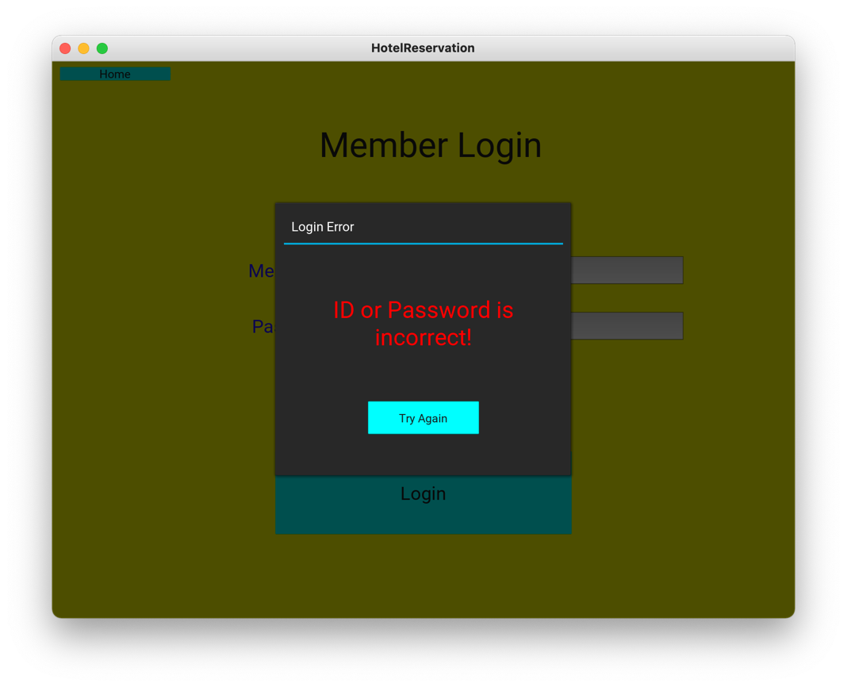

*Admin Login Screen*

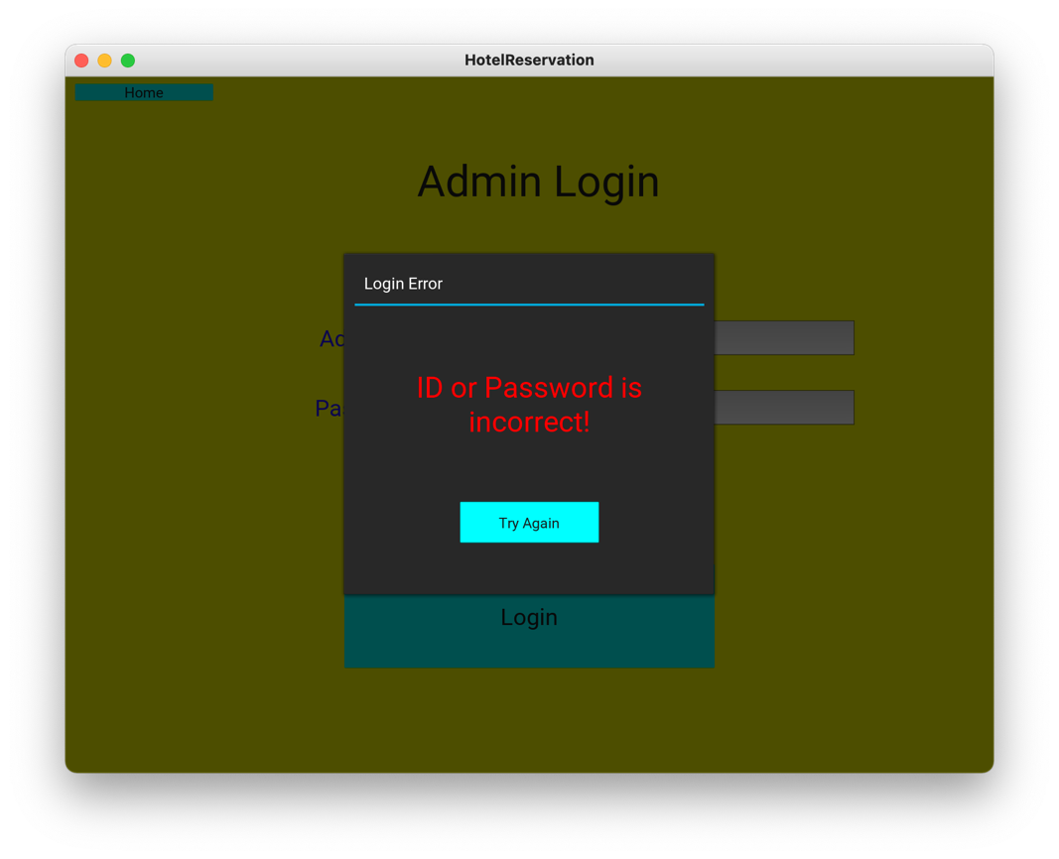

* *Booked rooms screen*

* *Checked-in rooms screen*

* *Create new admin screen*

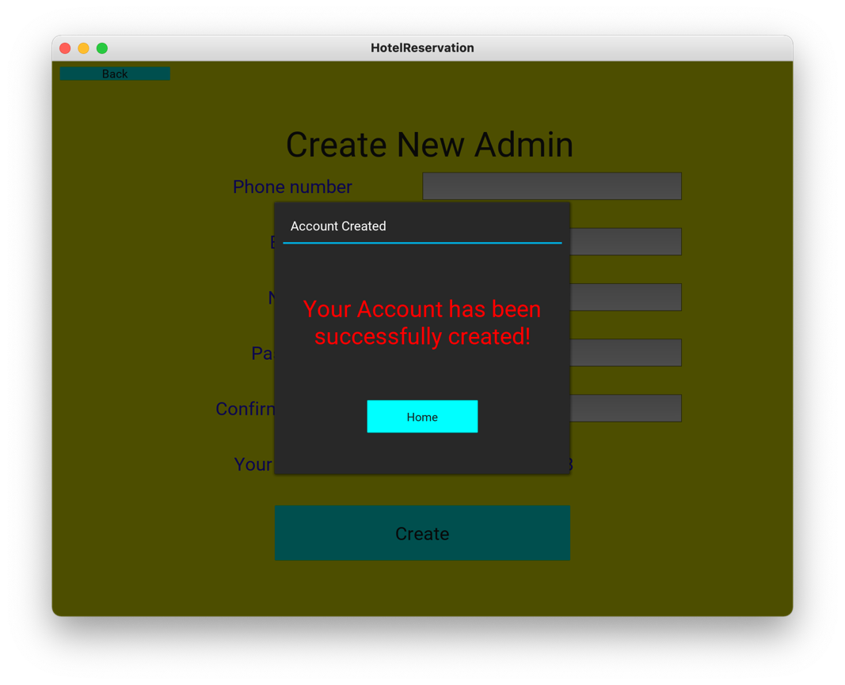

* *Create new room screen*

* *Admin account delete screen*

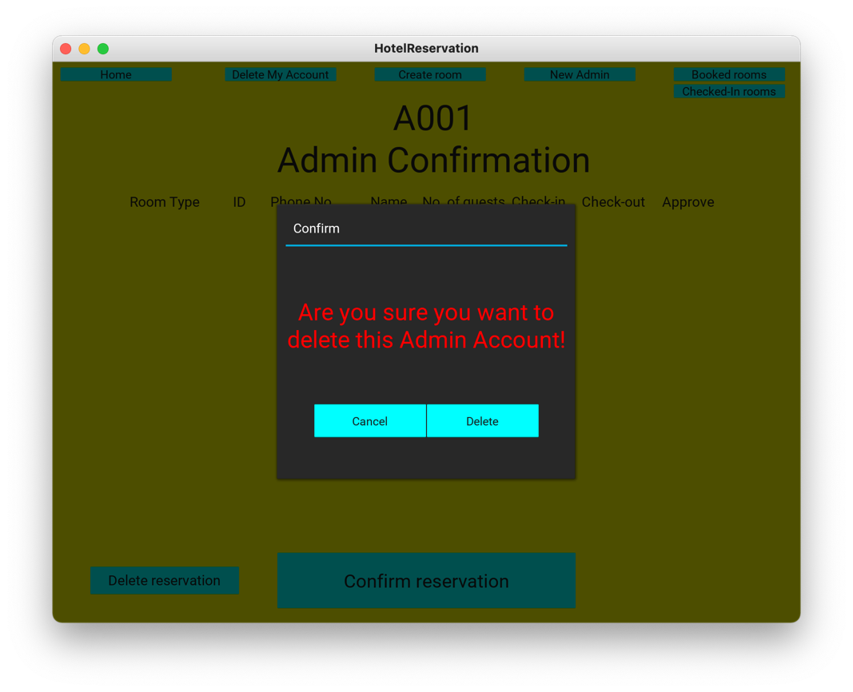

*Member Account Create Screen*

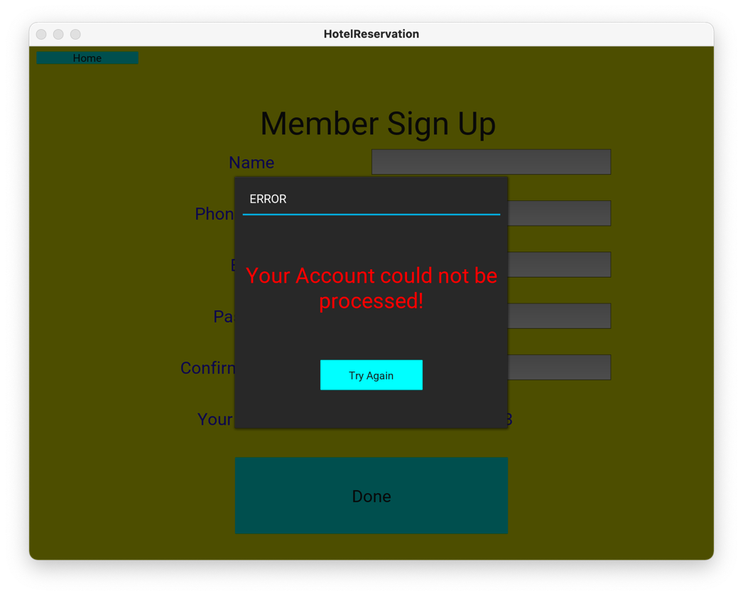

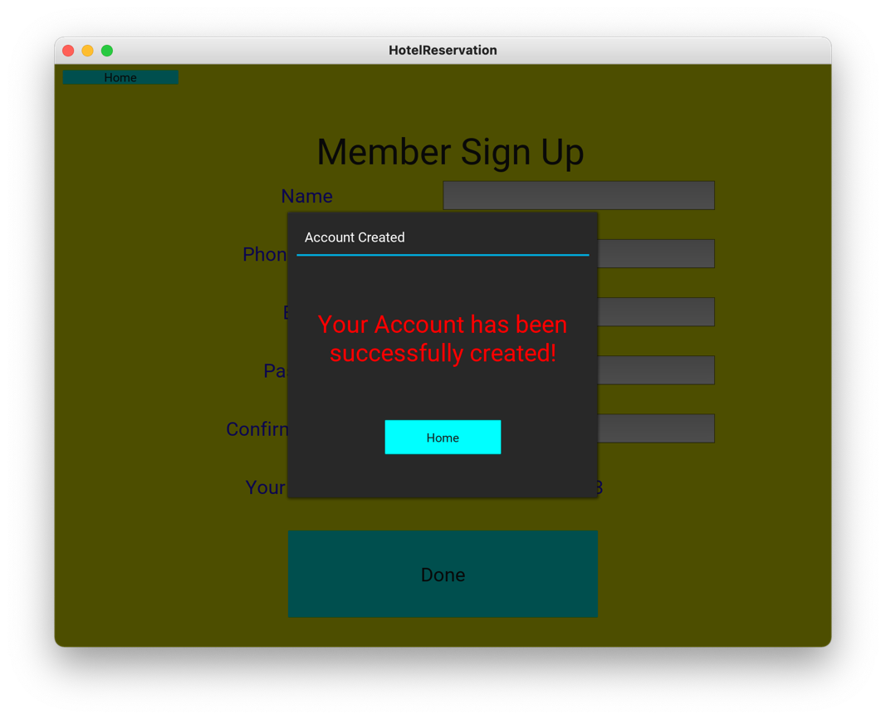

*Rooms Screen*

